Fundraising Channels
Let us explore three primary, high-impact channels that early-stage social enterprises often tap into: Crowdfunding, Angel/Impact Investors, and Corporate Social Responsibility (CSR). Each comes with its own process, strengths, and strategic fit.

- Crowdfunding: Mobilising the Power of the Crowd
Crowdfunding turns traditional fundraising on its head. Rather than relying on one large investor, it aggregates small contributions from a broad base of individuals, usually via digital platforms. It is not just about money—it is about momentum, validation, and storytelling.
https://www.freepik.com/free-vector/cheerful-guy-earning-money-his-idea_12290918.htm#fromView=search&page=1&position=6&uuid=f966d1c5-f74e-44df-8229-881e83a709d8&query=crowdfunding
Alt text: Crowdfunding concept
How it works
- The enterprise designs a campaign, typically on platforms like Ketto, Kickstarter, Milaap or GoFundMe, which are used to raise funds for causes like healthcare, education, emergencies, creative projects or community development.
- It builds a narrative that includes a mission-driven pitch, visuals, reward tiers (if applicable), and a timeline.
- The founder’s role is as much about community engagement as financial ask—leveraging social media, email lists, and offline networks to reach contributors.
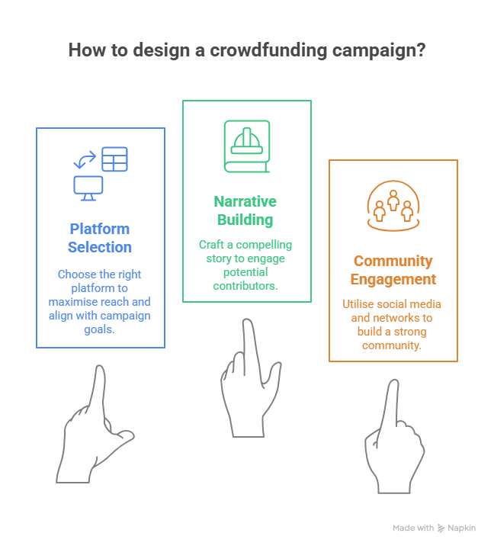
Built-in application
Take, for instance, a social startup creating solar-powered study lamps for children in off-grid villages. After identifying a ₹10 lakh requirement for their pilot phase—including lamp production, logistics to 1,000 households, and community training—they launched a crowdfunding campaign on Milaap.
https://www.freepik.com/free-vector/solar-power-plant-maintenance-utility-workers-repairing-electric-installations-boxes-towers-power-lines-electric-network-operation-city-service-renewable-energy-topics_10173574.htm#fromView=search&page=1&position=1&uuid=c6d98bdc-afc2-421b-b1e5-b7b69aa0b37f&query=solar+power+street+lights
Alt text: Solar power plants

Instead of going to large donors, they craft a story-driven campaign targeting 5,000 contributors with an average ask of ₹200 each. They amplify this via social media, school networks, and sustainability influencers. Within six weeks, they hit their goal—not just raising funds, but also validating demand, gathering early user feedback, and building a base of impact ambassadors who now feel emotionally invested in the mission.
Why it matters
Crowdfunding is not just a funding tool—it is a signal. A successful campaign demonstrates market validation, community support, and founder resilience, which in turn boosts confidence for future investors.
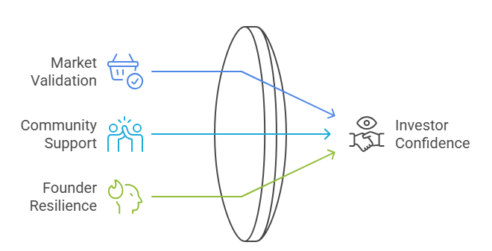

2. Angel Investors and Impact Investors: Strategic Capital with Purpose
Unlike conventional investors, angel and impact investors are looking beyond Return on Investment (ROI); they seek return on impact. This makes them especially suited to social enterprises, where financial success is intertwined with measurable social outcomes.
https://www.freepik.com/free-vector/angel-investor-abstract-concept-vector-illustration-startup-financial-support-business-startup-professional-advice-help-fundraising-online-crowdfunding-investment-capital-abstract-metaphor_12083703.htm#fromView=search&page=1&position=3&uuid=bcb2ed90-9893-44ee-a7b6-2f2fb9bc957a&query=angel+investors
Alt text: Angel investor
How it works
- Angel investors are typically high-net-worth individuals who invest personal funds into early-stage startups.
- Impact investors, family offices, funds, or foundations, use structured capital to support ventures creating social or environmental value.
- The process involves pitch decks, theory of change, revenue models, unit economics, and clear impact metrics.
- Due diligence here is not just financial, it includes an assessment of intent, mission alignment, and scalability of impact.
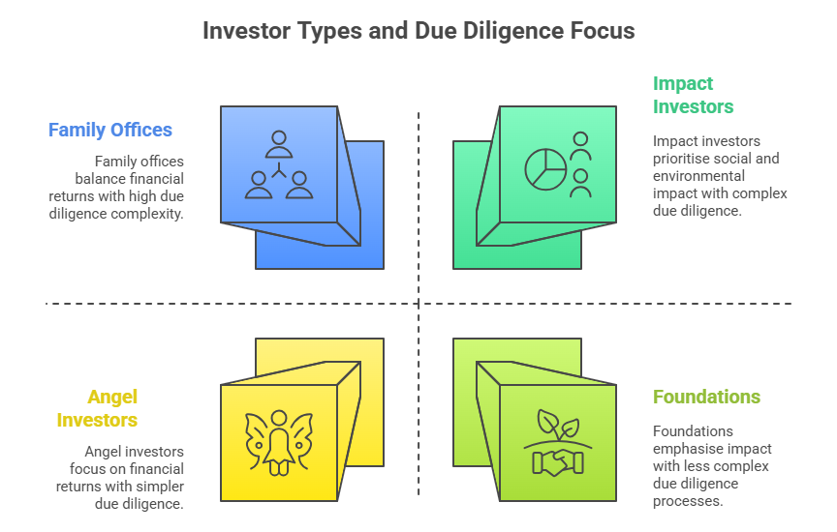
Built-in application
Consider a startup that trains women from low-income backgrounds to become solar technicians. An impact investor may be drawn to the dual outcomes—clean energy access and gender inclusion. They might invest ₹50 lakhs in exchange for equity, while also offering mentorship and network access. Here, funding becomes a partnership, where capital meets capability-building.
Why it matters
Angel and impact capital bring more than just money; they bring credibility, strategic guidance, and network leverage. For social entrepreneurs navigating ambiguous markets, this blend of support can be catalytic.

3. Corporate Social Responsibility (CSR): Mission Meets Mandate
CSR is often perceived as a grant-making function but for early-stage social enterprises, it can be a strategic funding pathway—especially in India where the CSR mandate compels certain companies to invest 2% of profits into social causes.
https://www.freepik.com/free-vector/flat-design-corporate-social-responsibility-concept-illustration_13442225.htm#fromView=search&page=1&position=17&uuid=d664a128-4610-4126-8c51-8972a841bee3&query=CSR+projects
Alt text: CSR illustration
How it works
- The enterprise aligns its mission with the thematic priorities of a corporate (e.g., education, health, livelihoods).
- The process typically involves submitting proposals, aligning with CSR compliance norms, demonstrating past impact (even if small-scale), and passing governance checks.
- Often structured as project-based grants or capacity-building partnerships (not equity investments).
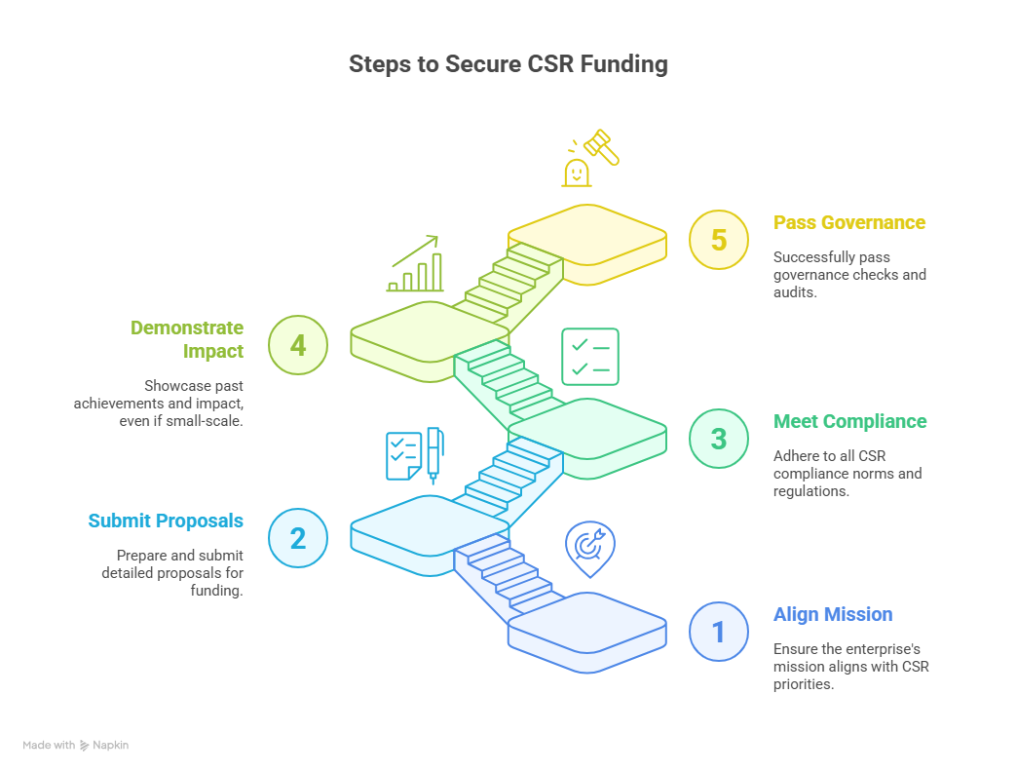
Built-in application
An edtech social enterprise creating vernacular STEM content for government schools may collaborate with a CSR partner in the education sector. The corporate funds ₹20 lakhs towards a pilot rollout across 50 schools, and in return, receives branded visibility, impact reports, and alignment with their mandated CSR goals.
Why it matters
CSR funding often allows flexibility; unlike venture capital, there is less pressure for fast returns. It also opens the door to strategic co-creation, where corporates offer resources beyond cash, like logistics, tech support, or access to last-mile networks.

Strategic Selection: Matching Channel to Context
Each of these fundraising channels serves a unique role, and the choice depends on:
- Stage of enterprise (idea, pilot, growth)
- Funding need (product development vs scaling vs ecosystem building)
- Type of impact (individual beneficiary vs systemic change)
- Founder capacity (networks, storytelling ability, governance maturity)
A thoughtful social entrepreneur does not chase all channels, they sequence them. For instance:
“Start with crowdfunding to build traction → Use success story to attract an angel investor → Leverage early results to pitch CSR partners for wider implementation.”
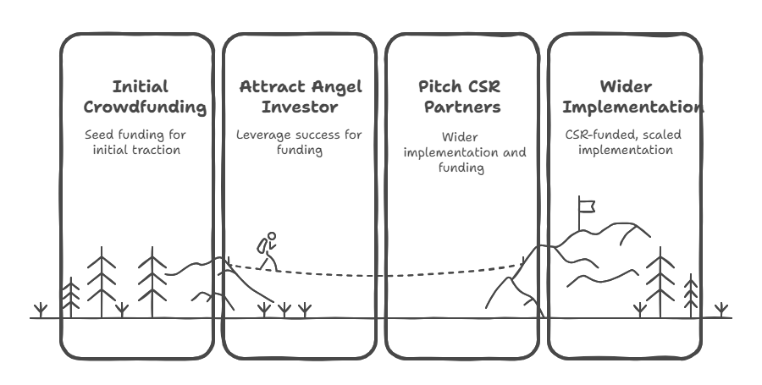
Created using napkin.ai

